


Farmer Loan Online Website

U15CS605R

Submitted by
MANIKANDAN M | (1518102069)
SETHUMADHAVAN J | (1518102127)

TAMILSELVAN K | (1518102145)

in partial fulfillment for the award of the degree
of

BACHELOR OF ENGINEERING

IN

COMPUTER SCIENCE ENGINEERING

SONA COLLEGE OF TECHNOLOGY

ANNA UNIVERSITY: CHENNAI 600 025

JUNE 2021

ANNA UNIVERSITY: CHENNAI – 600 025

BONAFIDE CERTIFICATE

Certified that this technical report FARMAR LOAN ONLINE WEBSITE the bonafide work of MANIKANDAN M(1518102069), SETHUMADHAVAN J(1518102127) and TAMILSELVAN K(1518102145) who carried out the project work under my supervision.

SIGNATURE

SIGNATURE

Dr.B.SATHIYABHAMA M.Tech, Ph.D.,

Prof.D.VIDYABHARATHI M.E.,

HEAD OF THE DEPARTMENT SUPERVISOR

Professor Associate Professor

Department of Computer Science and Department of Computer and Engineering
Engineering
Sona college of Technology Sona college of Technology
Salem. Salem.

Submitted for the project work viva-voce examination held on 12-06-2021………..

—————————

Internal Examiner

—————————

External Examiner

 | TABLE OF CONTENTS
CHAPTER NO | TITLE | PAGE NO
 | ABSTRACT | 4
1 | INTRODUCTION | 5
2 | LITERATURE SURVEY | 6
3 | PROPOSED SYSTEM | 8
4 | SYSTEM DESIGN | 9
5 | CONCLUSION | 15
 | REFERENCES | 16
 | APPENDIX | 17

ABSTRACT

A business objective of providing efficient loan process using technology as an enabler in order to give the company a competitive advantage within the industry suggests automation. Although a number of lenders have a certain kind of technology infused into their loan processing system, there are noticeable insufficiencies. Finding a guide to the design and creation of a loan automation system is also elusive. There is therefore the need for the creation of a loan automation application which this research addressed. Design and creation research strategy was adopted and data collection was through existing documents and structured interviews. Waterfall software development method was adopted. The outcome provides a loan automation application that saves paper works throughout the life of the loan, and its design is also available as a contributory guide towards creation of similar system. The farmer can view the loan availability from the website user can access the website and create an account (from the register for user’s only) and log in with their appropriate username and password. Once user login with our username and password then they see the loan application tab in the navigation bar through here user can apply the loan based on the required amount with submission of land document, aadhar card copy.

KEYWORDS: Farmers, Farmer online loan, Agriculture loan, Types of agriculture, Types of farming, Types of agriculture loans, Indian agriculture

CHAPTER 1

INTRODUCTION

A loan is a sum of money granted to an individual or an entity on the condition that it be repaid over a set period of time with interest as compensation for the use of the funds. Credits, finance, and mortgages are examples of numerous sorts of loans. Banks, credit unions, pawnbrokers, savings organisations, and trust businesses are all potential loan sources. For both the lender and the borrower, the manual loan application and approval procedure is stressful, cumbersome, and time consuming. A lender with geographically spread branch offices needs to standardise and oversee lending procedures and processes in a more effective and efficient manner. Automation is suggested by the business goal of delivering an efficient loan process using technology as an enabler to give the organisation a competitive advantage within the market (Bank System and Technology, 2013)[1]. There is a pressing need to automate as much of the loan processing process as feasible. A loan automation system (Christeson, 2009; WAUSAU, 2010)[2] facilitates the processing of loans from application to final confirmation without the physical presence of both the applicant and the lending institution. Despite the fact that a lot of lenders have incorporated technology into their loan processing systems, there remain glaring flaws. It's also difficult to come by a comprehensive guidance on the design and implementation of a loan automation system.
As a result, the purpose of this project is to design and develop loan automation application software that can only record the necessary loan data elements once and maintain it safe throughout the lending procedure, change the former manual system of obtaining and disbursing loans into an automated, less stressful system, Keep track of the people and organisations involved in the process, and monitor and track the loans that are given out to improve workflow and compliance with the terms, assure information security, shorten the time it takes for a loan to mature, Interest rates on loans should be appropriate., Identify and punish defaulters, and keep the individual or institution informed about the status of their loan. A review of prior studies on this research topic and associated issues (Claude, 2009; Croft, 2010; John, 2006; Srinivas, 2005; William, 2006; Witman & Roust, 2008)[3] was also conducted to help identify areas of concern and develop the suggested application.

CHATER 2
LITERATURE SURVEY
Obtaining a loan is not a simple task that anybody can complete; it is a time-consuming and hard process in our country. It could take weeks or months for the loan to be approved for the folks who applied for it. We are automating the loan procedure for both bankers and clients (farmers) in this project. Our customers (farmers) can view the availability of various loans offered by the bank, as well as the rates of interest and documentation required. Our programme will gather information about the customer's present situation/job, as well as the reason for the loan. In addition, we will request the customer's Aadhar number and bank account information to ensure a secure transaction between the user and the bank. Our customers (farmers) must produce some guarantee documents in order for us to trust that they will be able to repay the loan and grant it to them. According to our policy, our system or software attaches the smallest amount of interest to whatever credit the creditor requests. What is the aim of the loan, how much does he or she require, and will they be able to repay the loan to the bank within the time frame specified in the loan policies? Despite the fact that a lot of lenders have incorporated technology into their loan processing systems, there remain glaring flaws. It's also difficult to come by a comprehensive guidance on the design and implementation of a loan automation system. As a result, the purpose of this project is to design and develop loan automation software that can capture all of the essential loan data elements only once, keep such information secure throughout the loan process, convert the previous hand to hand system of obtaining and granting loans into a computerized less stressful form, Keep track of the people and organisations involved in the process, and monitor and track the loans that are given out to improve workflow and compliance with the terms, assure data security, minimise lending lifecycle times, apply suitable interest rates to loans, identify and penalise defaulters, and keep the concerned individual or institution informed about the status of their loan.
Design and creation is the research strategy (J Oates, 2010)[4]. Waterfall was chosen as the software development model because the project needs were clearly specified and understood before design and development began, and it provides a methodical method to software development that begins with a well-defined requirement, understands the client's requirements and follows a step-by-step process to implementation (Green & DiCaterino, 1998; Hughes & Cotterell, 2009; Night, Steinbach & Kellen, 2001; Whitten, Bently, & Dittman, 2001; Yin, 2003) [5]. Four banks' old systems were analysed, and the prerequisites for developing a better system that will eliminate or lessen the old system's stated flaws were determined. These requirements guided the proposed system's design phase, which included an initial system research, feasibility study, and system analysis before moving on to system design. During the system analysis, fact-finding techniques were used. A sufficient sample of data on the available files, decision points, and transactions handled by the current systems was obtained. Interviews and on-site observation were used in tandem to acquire data. In addition, secondary data on loans already provided to borrowers by the lending or financial institution, as well as repayment histories, was used. Personal interviews with the operators of the Entrepreneurship Development Program (EDP) were undertaken in order to analyse the scheme's impact on the lending institution's lending policy. A review of prior works on this study topic and related concerns is also included (Claude, 2009; Croft, 2010; John, 2006; Srinivas, 2005; William, 2006; Witman & Roust, 2008)[3] were also looked at to help
identify areas of concern and provide assistance.

CHAPTER 3

PROPOSED SYSTEM

In this Loan applying system, First the applicant will apply for the loan that he wants for his future purpose. That application will reach the Loan verifier in inclusive with application form the applicant have to attach some verification form. The Loan verifier will look into the application form then he/She will check whether the verification document submitted by the applicant is valid or not. Based on the report submitted by the Loan verifier the Loan Evaluator will make his/her decision whether to Accept/Reject the application form. After Accepting/Rejecting the Loan Evaluator will contact the applicant and deliver him the report about the loan.Then the applicant will take the report and give it to the Loan collector. While giving the report to the Loan collector the applicant also attach some installment documents with it for verification as shown in fig.1

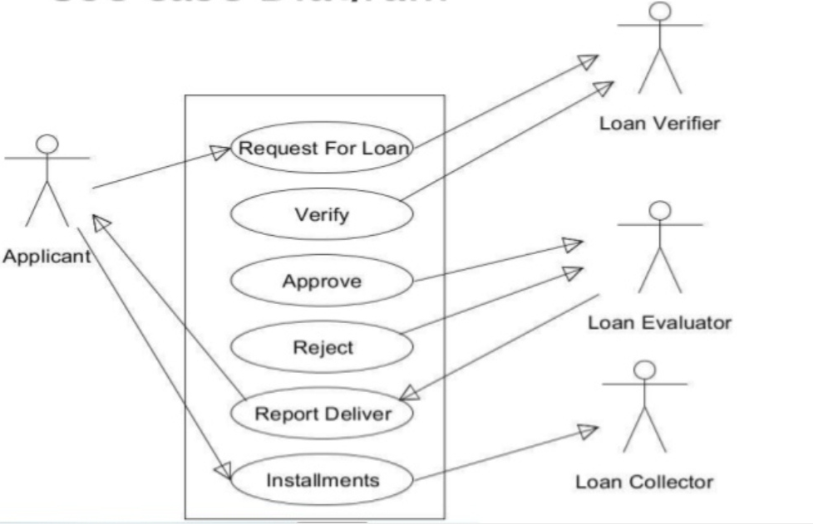

Fig.1 System Design

CHAPTER 4

SYSTEM DESIGN

The software development environment for the creation of this Loan automation application software includes Hypertext Markup Language (HTML), WAMP server (Windows Apache Microsoft PHP) or XAMPP(cross-platform, Apache, MySQL, PHP and Perl), Javascript, CSS (Cascading Style Sheet), PHP (Hypertext Preprocessor), and MySQL. Web browser. The platform on which the application will run includes windows 7 operating system and the software can run on any operating system, and a web browser such as Mozilla Firefox, Opera, and Internet explorer. The website contains both admin and user side. The Fig2 will show the new user register window. In that the user have to enter their Name, Date of Birth, Gender, Contact No, Permanent Address, State, Password, and Confirmation Password. At last after filling all the details the user have to click the Register button. The user can view the loan availability from the website as shown in Fig4.
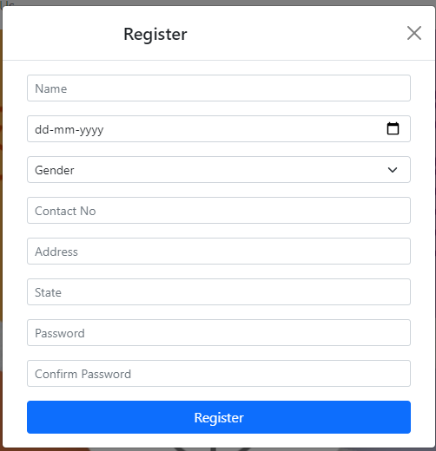
Fig.2 Register Page

The Figure.3 is the Login page for the applicants who wants to apply for the loan. In this the applicant have to enter the valid Name and Password which will be provided from the admin end.
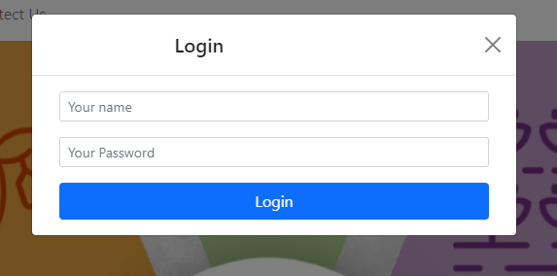
Fig.3 User Login Page
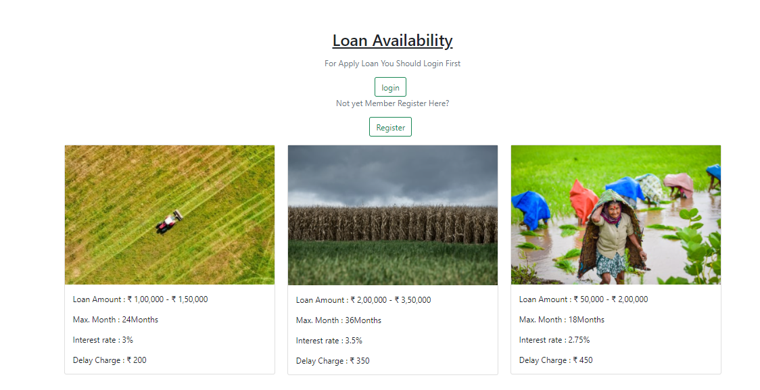
Fig.4 Loan Availability

Both admin and user can access the website and create an account (from the register for user’s only) and log in with their appropriate username and password. Once user login with our username and password then they see the loan application tab in the navigation bar (Fig5) through here user can apply the loan based on the required amount with submission of land document, aadhar card copy. The document and aadhar is for verification purpose, once user applies for the loan then he/she has to wait till the verification as finished. Once the verification done the user will receive the notification on the loan offer tab with emi table(as shown in Fig6).User can pay the loan amount through online as mentioned in the emi table for that following months. After the payment is done, they can see the the payment receipt as shown in Fig7.
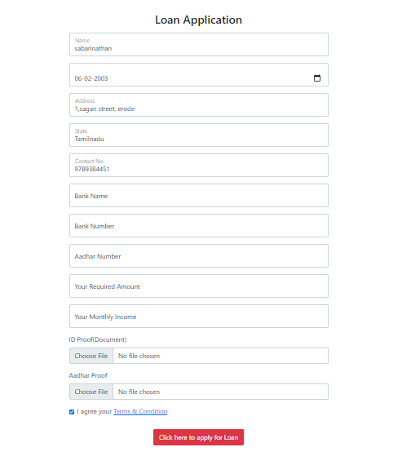
Fig.5 Loan Application

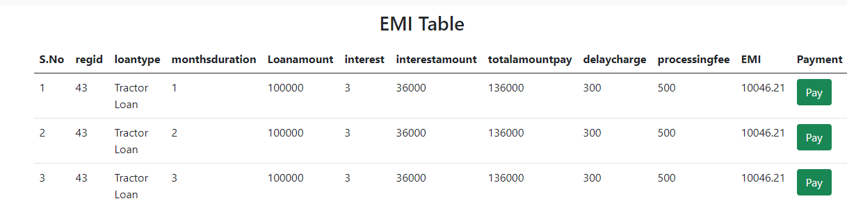

Fig.6 EMI Table



Fig.7 Payment
In admin side, admin can view the pending loan application in the navigation bar with the count of pending application as notification. Admin gets to view the various details of the loan applicants such as, the loan applicant’s personal details, require loan amount, proof (aadhar, land document)and the interest can be viewed by clicking on the interest button(Fig8). When the admin clicks on the interest button the admin can view the loan type, month of duration, interest rate, total interest amount, total amount, delay charge , processing fee. After going through all the details, he admin decides to either accept or reject the loan by clicking on the accept or reject button as shown in the Fig9. Once admin accepts the loan application, the user can get the amount from the bank.

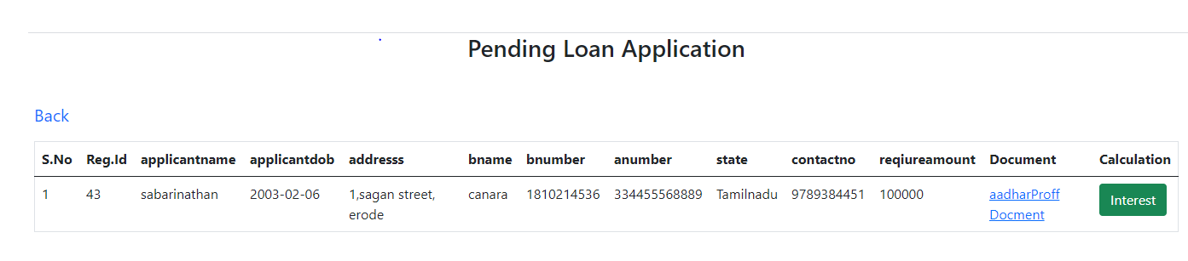
Fig.8 Pending Application

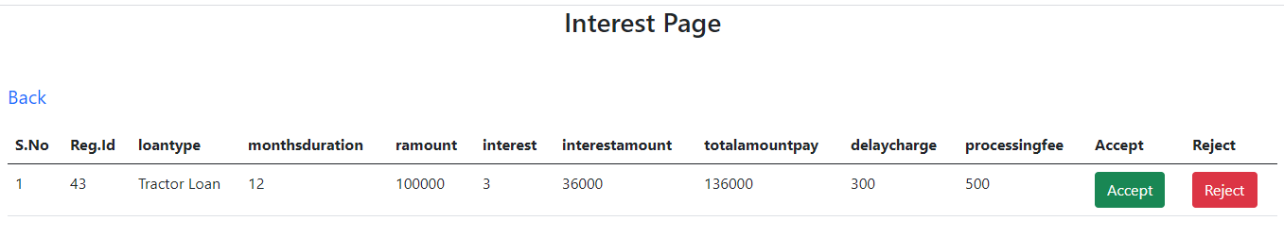
Fig.9 Interest Page

The admin can sort the loan application based on various amount categories and view the details as shown in the Fig10.

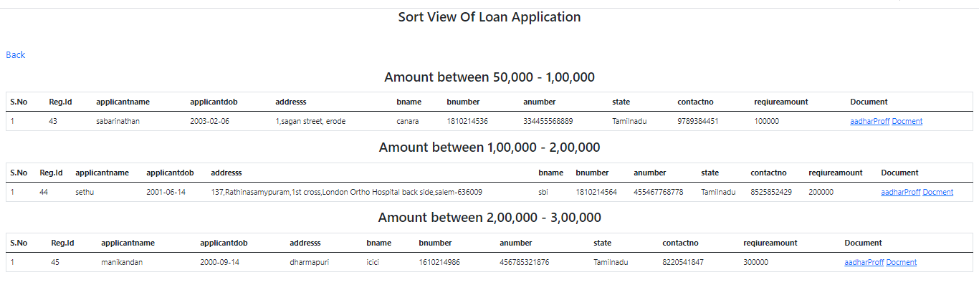
Fig.10 Sort View

CHAPTER 5

CONCLUSION
Farmers are the backbone of the country and every citizen depends on farmers for food and living. In order to save farmers and their profession government has been taking many steps and providing them with a lot of privileges. Similarly, we would like to contribute towards our farmers and developed a website where the farmers can ask and apply for loans based on the required amount. And the farmers can withdraw the amount immediately after their loan is sanctioned. This website is a great advantage for farmers as they do not have to worry about travelling long distances for reaching banks, applying for loans and continuously visiting them for verifications. This also saves lot of their time by letting them know if their loan is sanctioned or not through online itself and makes the work easier for both the banker and the farmer. All they have to do is just provide proper documents for proof and verification. As the future work, we would like to work on approving multiple loans for the farmers since our current website allows farmers to select and apply only for a single loan. Therefore, implementing the multiple loan concept helps farmers to apply different loans for different requirements.

REFERENCES

[1] Three-dimensional virtual bone bank system workflow for structural bone allograft selection: a technical report
LE Ritacco, GL Farfalli, FE Milano, MA Ayerza… - Sarcoma, 2013

[2] Creation of Loan Automation Application
AO Adebayo, A Zandra… - Global Journal of …, 2014 - publication.babcock.edu.ng

[3] The US Foreign Sovereignty Immunity Act and Its Application to Nazi-Appropriated Works of Art: Claude Cassirer v. Kingdom of Spain
K Chamberlain - Art Antiquity & L., 2006 – HeinOnline

[4] Implementing RFID at the University of Queensland law library: a review of the first year
J Oates - Austl. L. Libr., 2010

[5] One‐dimensional nanostructures: synthesis, characterization, and applications
…, B Mayers, B Gates, Y Yin, F Kim, H Yan - Advanced …, 2003

APPENDIX

SOURCE CODE

<?php
include "./includes/header.php";
?>
<body>
<!-- nav -->
<nav class="navbar navbar-expand-lg navbar-light bg-light">
<div class="container">
<a class="navbar-brand" href="#">FarLoanee</a>
<button class="navbar-toggler" type="button" data-bs-toggle="collapse" data-bs-target="#navbarSupportedContent" aria-controls="navbarSupportedContent" aria-expanded="false" aria-label="Toggle navigation">
<span class="navbar-toggler-icon"></span>
</button>
<div class="collapse navbar-collapse" id="navbarSupportedContent">
<ul class="navbar-nav me-auto mb-2 mb-lg-0">
<li class="nav-item">
<a class="nav-link active" aria-current="page" href="#">Home</a>
</li>
<li class="nav-item">
<a class="nav-link" href="#">About Us</a>
</li>
<li class="nav-item">
<a class="nav-link" href="#">Contect Us</a>
</li>
</ul>
<div class="d-flex">
<button type="button" class="btn btn-outline-success me-2" data-bs-toggle="modal" data-bs-target="#user_login">login</button>
<button type="button" class="btn btn-outline-success me-2" data-bs-toggle="modal" data-bs-target="#user_register">Register</button>
</div>
</div>
</div>
</nav>
<!-- nav -->
<!-- banner -->
<div class="container-fluid">
<img src="img/1.jpeg" style="width: 100%;height: 600px;object-fit: cover;">
</div>
<!-- banner -->

<!-- body content -->
<div class="home-body-content">
<h2 class="text-center text-decoration-underline mb-3">Loan Availability</h2>
<div class="container">
<p class="text-muted text-center">For Apply Loan You Should Login First</p>
<div class="d-flex justify-content-center">
<button type="button" class="btn btn-outline-success me-2" data-bs-toggle="modal" data-bs-target="#user_login">login</button>
</div>
<p class="text-muted text-center">Not yet Member Register Here?</p>
<div class="d-flex justify-content-center mb-3">
<button type="button" class="btn btn-outline-success me-2" data-bs-toggle="modal" data-bs-target="#user_register">Register</button>
</div>
<!-- <div class="d-flex justify-content-center mb-3">
<button type="button" class="btn btn-outline-success me-2" data-bs-toggle="modal" data-bs-target="#user_login">login</button>
<button type="button" class="btn btn-outline-success me-2" data-bs-toggle="modal" data-bs-target="#user_register">Register</button>
</div> -->
<div class="row">
<div class="col-lg-4 col-md-4">
<div class="card my_card">
<img src="img/agri1.png" alt="Banner">
<div class="card-body">
<p class="card-text">Loan Amount : <span>₹ 1,00,000 - ₹ 1,50,000</span></p>
<p class="card-text">Max. Month : <span>24Months</span></p>
<p class="card-text">Interest rate : <span>3%</span></p>
<p class="card-text">Delay Charge : <span>₹ 200</span></p>
</div>
</div>
</div>
<div class="col-lg-4 col-md-4">
<div class="card my_card">
<img src="img/agri2.jpg" alt="Banner">
<div class="card-body">
<p class="card-text">Loan Amount : <span>₹ 2,00,000 - ₹ 3,50,000</span></p>
<p class="card-text">Max. Month : <span>36Months</span></p>
<p class="card-text">Interest rate : <span>3.5%</span></p>
<p class="card-text">Delay Charge : <span>₹ 350</span></p>
</div>
</div>
</div>
<div class="col-lg-4 col-md-4">
<div class="card my_card">
<img src="img/agri3.jpg" alt="Banner">
<div class="card-body">
<p class="card-text">Loan Amount : <span>₹ 50,000 - ₹ 2,00,000</span></p>
<p class="card-text">Max. Month : <span>18Months</span></p>
<p class="card-text">Interest rate : <span>2.75%</span></p>
<p class="card-text">Delay Charge : <span>₹ 450</span></p>
</div>
</div>
</div>
</div>
</div>
</div>
<!-- body content -->
<?php
include "./includes/footer.php"
?>
<!-- user login -->
<div class="modal fade" id="user_login" tabindex="-1" aria-labelledby="exampleModalLabel" aria-hidden="true">
<div class="modal-dialog">
<div class="modal-content">
<div class="modal-header">
<h5 class="modal-title mx-auto" id="exampleModalLabel">Login</h5>
<button type="button" class="btn-close" data-bs-dismiss="modal" aria-label="Close"></button>
</div>
<div class="modal-body">
<div class="container">
<form action="userregister.php" method="POST">
<div class="mb-3">
<input type="text" name="unameLog" class="form-control form-control-sm" placeholder="Your name">
</div>
<div class="mb-3">
<input type="password" name="passlog" class="form-control form-control-sm" placeholder="Your Password">
</div>
<div class="d-grid gap-2 mx-auto">
<button class="btn btn-primary" name="logBtn" type="submit">Login</button>
</div>
</form>
</div>
</div>
</div>
</div>
</div>
<!-- user login -->
<!-- user register -->
<div class="modal fade" id="user_register" tabindex="-1" aria-labelledby="exampleModalLabel" aria-hidden="true">
<div class="modal-dialog">
<div class="modal-content">
<div class="modal-header">
<h5 class="modal-title mx-auto" id="exampleModalLabel">Register</h5>
<button type="button" class="btn-close" data-bs-dismiss="modal" aria-label="Close"></button>
</div>
<div class="modal-body">
<div class="container">
<form action="userregister.php" method="POST">
<div class="mb-3">
<input type="text" name="uname" class="form-control form-control-sm" placeholder="Name" required>
</div>
<div class="mb-3">
<input type="date" name="dob" class="form-control form-control-sm" placeholder="DOB" required>
</div>
<select class="form-select form-select-sm mb-3" name="gender" aria-label=".form-select-lg example" required>
<option selected>Gender</option>
<option value="male">Male</option>
<option value="Female">Female</option>
</select>
<!-- <div class="mb-3">
<input type="text" name="gender" class="form-control form-control-sm" placeholder="Gender" required>
</div> -->
<div class="mb-3">
<input type="text" name="contact" class="form-control form-control-sm" placeholder="Content No" required>
</div>
<div class="mb-3">
<input type="text" name="address" class="form-control form-control-sm" placeholder="Address" required>
</div>
<div class="mb-3">
<input type="text" name="state" class="form-control form-control-sm" placeholder="State" required>
</div>
<div class="mb-3">
<input type="password" name="pass" class="form-control form-control-sm" placeholder="Password" required>
</div>
<div class="mb-3">
<input type="password" name="cpass" class="form-control form-control-sm" placeholder="Confirm Password" required>
</div>
<div class="d-grid gap-2 mx-auto">
<button class="btn btn-primary" name="regBtn" type="submit">Register</button>
</div>
</form>
</div>
</div>
</div>
</div>
</div>
<!-- user register -->
<!-- Admin Login -->
<div class="modal fade" id="admin_login" tabindex="-1" aria-labelledby="exampleModalLabel" aria-hidden="true">
<div class="modal-dialog">
<div class="modal-content">
<div class="modal-header">
<h5 class="modal-title mx-auto" id="exampleModalLabel">Login As Admin</h5>
<button type="button" class="btn-close" data-bs-dismiss="modal" aria-label="Close"></button>
</div>
<div class="modal-body">
<div class="container">
<form action="adminlogin.php" method="POST">
<div class="mb-3">
<input type="email" class="form-control form-control-sm" name="email" placeholder="Your Email ID" required>
</div>
<div class="mb-3">
<input type="password" class="form-control form-control-sm" name="pass" placeholder="Your Password" required>
</div>
<div class="d-grid gap-2 mx-auto">
<button class="btn btn-primary" type="submit" name="btn">Login</button>
</div>
</form>
</div>
</div>
</div>
</div>
</div>
<!-- Admin Login -->
<!-- Optional JavaScript; choose one of the two! -->
<!-- Option 1: Bootstrap Bundle with Popper -->
<script src="https://cdn.jsdelivr.net/npm/bootstrap@5.0.1/dist/js/bootstrap.bundle.min.js" integrity="sha384-gtEjrD/SeCtmISkJkNUaaKMoLD0//ElJ19smozuHV6z3Iehds+3Ulb9Bn9Plx0x4" crossorigin="anonymous"></script>
</body>
</html>

<?php
include_once "includes/config.php";
include_once "./includes/header.php"
?>
<body>
<h3 class="text-center mb-3">Pending Loan Application</h3>
<div class="container-fluid mt-5">
<p class="text-muted fs-5 mt-3"><a href="adminhome.php" class="text-decoration-none">Back</a></p>
<table class="table table-stripped border">
<thead>
<tr>
<th scope="col">S.No</th>
<th scope="col">Reg.Id</th>
<th scope="col">applicantname</th>
<th scope="col">applicantdob</th>
<th scope="col">addresss</th>
<th scope="col">bname</th>
<th scope="col">bnumber</th>
<th scope="col">anumber</th>
<th scope="col">state</th>
<th scope="col">contactno</th>
<th scope="col">reqiureamount</th>
<th scope="col">Document</th>
<th scope="col">Calculation</th>
<!-- <th scope="col">Accept</th>
<th scope="col">Reject</th> -->
</tr>
</thead>
<tbody>
<?php
$sql_sel = "SELECT * FROM loanapp WHERE status = 0";
$sno = 1;
$res = mysqli_query($con, $sql_sel);
$cnt = mysqli_num_rows($res);

if($cnt > 0){
while($row = mysqli_fetch_assoc($res)):
?>
<tr>
<td><?php echo $sno++ ?></td>
<td>
<?php
$regid = $row['regid'];
echo $regid;
?>
</td>
<td><?php echo $row['applicantname']?></td>
<td><?php echo $row['applicantdob']?></td>
<td><?php echo $row['addresss']?></td>
<td><?php echo $row['bname']?></td>
<td><?php echo $row['bnumber']?></td>
<td><?php echo $row['anumber']?></td>
<td><?php echo $row['state']?></td>
<td><?php echo $row['contactno']?></td>
<td>
<?php
(int)$reqamount = $row['reqiureamount'];
echo $reqamount;
?>
</td>
<td>
<a href="img/document/<?php echo $row['aadhar']?>" target="_blank" class="mb-3">aadharProff</a>
<a href="img/document/<?php echo $row['document']?>" target="_blank" class="mb-3">Docment</a>
</td>
<?php
if(isset($_GET['calcinterest'])){
$int_id = $_GET['calcinterest'];
if($int_id == $regid){
echo '<td><a href="viewinterest.php?interestid='.$row['regid'].'" name = "accept" class="btn btn-success">View Interest</a></td>';
}else if($int_id != $regid){
echo '<td><a href="viewinterest.php?interestid='.$row['regid'].'" name = "accept" class="btn btn-success">Interest</a></td>';
}
}
else{
echo '<td><a href="interest.php?interestid='.$row['regid'].'" name = "accept" class="btn btn-success">Interest</a></td>';
}
?>
</tr>
<?php endwhile?>
<?php
}
else{
//echo "error";
}
?>
</tbody>
</table>
</div>
</body>
</html>
<?php
include_once "interest.php";
?>

<?php
include_once "includes/config.php";

include_once "./includes/header.php"
?>
<body>
<h3 class="text-center mb-3">Sort View Of Loan Application</h3>
<div class="container-fluid mt-5">
<p class="text-muted fs-5 mt-3"><a href="adminhome.php" class="text-decoration-none">Back</a></p>
<table class="table table-stripped border">
<thead>
<h3 class="text-center mb-3">Amount between 50,000 - 1,00,000</h3>
<tr>
<th scope="col">S.No</th>
<th scope="col">Reg.Id</th>
<th scope="col">applicantname</th>
<th scope="col">applicantdob</th>
<th scope="col">addresss</th>
<th scope="col">bname</th>
<th scope="col">bnumber</th>
<th scope="col">anumber</th>
<th scope="col">state</th>
<th scope="col">contactno</th>
<th scope="col">reqiureamount</th>
<th scope="col">Document</th>
</tr>
</thead>
<tbody>
<?php
$sql_sel = "SELECT * FROM loanapp WHERE reqiureamount >= 50000 and reqiureamount <=100000"; $sno = 1;
$res = mysqli_query($con, $sql_sel);
$cnt = mysqli_num_rows($res);

if($cnt > 0){
while($row = mysqli_fetch_assoc($res)):
?>
<tr>
<td><?php echo $sno++ ?></td>
<td>
<?php
$regid = $row['regid'];
echo $regid;
?>
</td>
<td><?php echo $row['applicantname']?></td>
<td><?php echo $row['applicantdob']?></td>
<td><?php echo $row['addresss']?></td>
<td><?php echo $row['bname']?></td>
<td><?php echo $row['bnumber']?></td>
<td><?php echo $row['anumber']?></td>
<td><?php echo $row['state']?></td>
<td><?php echo $row['contactno']?></td>
<td>
<?php
(int)$reqamount = $row['reqiureamount'];
echo $reqamount;
?>
</td>
<td>
<a href="img/document/<?php echo $row['aadhar']?>" target="_blank" class="mb-3">aadharProff</a>
<a href="img/document/<?php echo $row['document']?>" target="_blank" class="mb-3">Docment</a>
</td>
</tr>
<?php endwhile?>
<?php
}
else{
//echo "error";
}
?>
</tbody>
</table>

<table class="table table-stripped border">
<thead>
<h3 class="text-center mb-3">Amount between 1,00,000 - 2,00,000</h3>
<tr>
<th scope="col">S.No</th>
<th scope="col">Reg.Id</th>
<th scope="col">applicantname</th>
<th scope="col">applicantdob</th>
<th scope="col">addresss</th>
<th scope="col">bname</th>
<th scope="col">bnumber</th>
<th scope="col">anumber</th>
<th scope="col">state</th>
<th scope="col">contactno</th>
<th scope="col">reqiureamount</th>
<th scope="col">Document</th>
</tr>
</thead>
<tbody>
<?php
$sql_sel = "SELECT * FROM loanapp WHERE reqiureamount > 100000 and reqiureamount <=200000"; $sno = 1;
$res = mysqli_query($con, $sql_sel);
$cnt = mysqli_num_rows($res);

if($cnt > 0){
while($row = mysqli_fetch_assoc($res)):
?>
<tr>
<td><?php echo $sno++ ?></td>
<td>
<?php
$regid = $row['regid'];
echo $regid;
?>
</td>
<td><?php echo $row['applicantname']?></td>
<td><?php echo $row['applicantdob']?></td>
<td><?php echo $row['addresss']?></td>
<td><?php echo $row['bname']?></td>
<td><?php echo $row['bnumber']?></td>
<td><?php echo $row['anumber']?></td>
<td><?php echo $row['state']?></td>
<td><?php echo $row['contactno']?></td>
<td>
<?php
(int)$reqamount = $row['reqiureamount'];
echo $reqamount;
?>
</td>
<td>
<a href="img/document/<?php echo $row['aadhar']?>" target="_blank" class="mb-3">aadharProff</a>
<a href="img/document/<?php echo $row['document']?>" target="_blank" class="mb-3">Docment</a>
</td>
</tr>
<?php endwhile?>
<?php
}
else{
//echo "error";
}
?>
</tbody>
</table>

<table class="table table-stripped border">
<thead>
<h3 class="text-center mb-3">Amount between 2,00,000 - 3,00,000</h3>
<tr>
<th scope="col">S.No</th>
<th scope="col">Reg.Id</th>
<th scope="col">applicantname</th>
<th scope="col">applicantdob</th>
<th scope="col">addresss</th>
<th scope="col">bname</th>
<th scope="col">bnumber</th>
<th scope="col">anumber</th>
<th scope="col">state</th>
<th scope="col">contactno</th>
<th scope="col">reqiureamount</th>
<th scope="col">Document</th>
</tr>
</thead>
<tbody>
<?php
$sql_sel = "SELECT * FROM loanapp WHERE reqiureamount > 200000 and reqiureamount <=300000"; $sno = 1;
$res = mysqli_query($con, $sql_sel);
$cnt = mysqli_num_rows($res);

if($cnt > 0){
while($row = mysqli_fetch_assoc($res)):
?>
<tr>
<td><?php echo $sno++ ?></td>
<td>
<?php
$regid = $row['regid'];
echo $regid;
?>
</td>
<td><?php echo $row['applicantname']?></td>
<td><?php echo $row['applicantdob']?></td>
<td><?php echo $row['addresss']?></td>
<td><?php echo $row['bname']?></td>
<td><?php echo $row['bnumber']?></td>
<td><?php echo $row['anumber']?></td>
<td><?php echo $row['state']?></td>
<td><?php echo $row['contactno']?></td>
<td>
<?php
(int)$reqamount = $row['reqiureamount'];
echo $reqamount;
?>
</td>
<td>
<a href="img/document/<?php echo $row['aadhar']?>" target="_blank" class="mb-3">aadharProff</a>
<a href="img/document/<?php echo $row['document']?>" target="_blank" class="mb-3">Docment</a>
</td>
</tr>
<?php endwhile?>
<?php
}
else{
//echo "error";
}
?>
</tbody>
</table>
</div>
</body>
</html>
<?php
include_once "interest.php";
?>

